**Introduction to PHP**

**LAB: 06**

**Spring-22**

Submitted by: **Ashfaq Ahmad**

Registration No: **19PWCSE1795**

Class Section: **B**

Student Signature: ______________

Submitted to:

**Engr.Naina Said**

July 25, 2022

Department of Computer Systems Engineering

University of Engineering and Technology, Peshawar

**Task01:**

Create a simple calculator using php. The calculator should collect the operands as well as the operator from the user using html form. (hint: Use Switch)

Source Code:

<!DOCTYPE html>

<head>

    <title>Simple Calculator Program in PHP</title>

</head>

<?php

$first_num = $_POST['first_num'];

$second_num = $_POST['second_num'];

$operator = $_POST['operator'];

$result = '';

if (is_numeric($first_num) && is_numeric($second_num)) {

    switch ($operator) {

        case "Add":

           $result = $first_num + $second_num;

            break;

        case "Subtract":

           $result = $first_num - $second_num;

            break;

        case "Multiply":

            $result = $first_num * $second_num;

            break;

        case "Divide":

            $result = $first_num / $second_num;

    }

}

?>

<body>

    <div id="page-wrap">

    <h1>PHP - Simple Calculator Program</h1>

      <form action="" method="post" id="quiz-form">

            <p>

                <input type="number" name="first_num" id="first_num" required="required" value="<?php echo $first_num; ?>" /> <b>First Number</b>

            </p>

            <p>

                <input type="number" name="second_num" id="second_num" required="required" value="<?php echo $second_num; ?>" /> <b>Second Number</b>

            </p>

            <p>

                <input readonly="readonly" name="result" value="<?php echo $result; ?>"> <b>Result</b>

            </p>

            <input type="submit" name="operator" value="Add" />

            <input type="submit" name="operator" value="Subtract" />

            <input type="submit" name="operator" value="Multiply" />

            <input type="submit" name="operator" value="Divide" />

      </form>

    </div>

</body>

</html>

**Output:**

**Multiplication:**

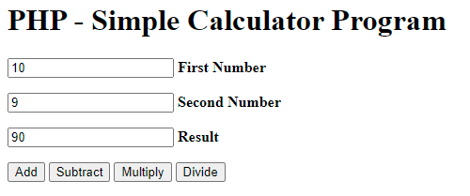

**Addition:**

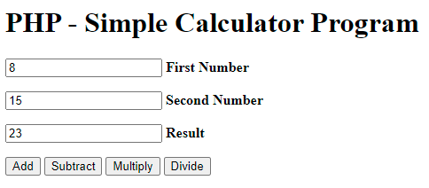

**Task02:**

Write a php function which creates the pattern as shown in the figure below. Please note that the number of rows/cols should be dynamic. (i.e, the function can print the pattern depending on the number of rows/cols passed to it).

**Source Code:**

<!DOCTYPE html>

     <html>

     <head>

  <title>Lab6_Task2</title>

  <meta http-equiv="Content-Type" content="text/html; charset=UTF-8">

  </head>

  <body>

  <h3>Pattern Design</h3>

   <table width="270px" cellspacing="0px" cellpadding="0px" border="1px">

   <!-- cell 270px wide (8 columns x 60px) -->

      <?php

      for($row=1;$row<=8;$row++)

      {

          echo "<tr>";

          for($col=1;$col<=8;$col++)

          {

          $total=$row+$col;

          if($total%2==0)

          {

          echo "<td height=30px width=30px bgcolor=#FFFFF></td>";

          }

          else

          {

          echo "<td height=30px width=30px bgcolor=#FF00></td>";

          }

          }

          echo "</tr>";

    }

          ?>

  </table>

  </body>

  </html>

**Output:**



**Task03:**

Create a html form which collects information from students (name, email address, address, gender, telephone number). The form must also have photo upload option. As soon as the user clicks “submit” button, he is redirected to another page where the following message appears “Thank you for providing the information. Your data has been submitted successfully”.

**Source Code:**

<!DOCTYPE html>

<html lang="en">

<head>

    <meta charset="UTF-8">

    <meta http-equiv="X-UA-Compatible" content="IE=edge">

    <meta name="viewport" content="width=device-width, initial-scale=1.0">

    <title>Form</title>

</head>

<body>

    <form method="post" action="greetings.php">

        <label for="fname"> First Name</label>

        <br>

        <input type="text" name="fname" id="fname"> <br />

        <label for="lname"> Last Name</label>

        <br>

        <input type="text" name="lname" id="lname"> <br />

        <label for="gender"> Gender</label>

        <br>

        <select name="gender" id="gender">

            <option value="male">Male</option>

            <option value="female">Female</option>

        </select>

        <br>

        <br>

        <label for="email"> Email</label>

        <br>

        <input type="email" name="email" id="email"> <br />

        <br>

        <input type="submit" value="submit">

    </form>

</body>

</html>

<?php

    $first_name = $_POST['fname'];

    $last_name = $_POST['lname'];

    $email=$_POST['email'];

        $gender=$_POST['gender'];

    if (empty($first_name) && empty($last_name)){

      echo "<h1> Thank you for providing the information. Your data has been submitted successfully </h1>";

      echo "<br>";

    }

    else{

        echo " <h1> Hello ".$first_name ." ".$last_name

        ." Thank you for providing the information. Your data has been submitted successfully</h1>";

    }

?>

**Output:**

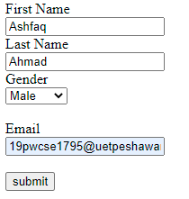

**Task04:**

Install Laravel on your system.

**Steps:**

